In Vivo Study of the Anticancer Activity of Doxorubicin Loaded on a Cellulose-Based Nanocarrier System
Tiba Majid Hammed*, Prof. Dr. Ashour Hamood Dawood**, Assist. Prof.Dr.Inaam Sameh Arif ***, lec. Yahya Dreaim Saihood****
* Department of Pharmaceutical Chemistry, College of Pharmacy, Al-Mustanisiriyah University
** Department of Pharmacy, Al- Israa University College
*** Department of Pharmacology and Toxicology, College of Pharmacy, Al-Mustansiriya University,
**** Iraqi Center for Cancer and Medical Genetics Research, Al-Mustansiriya University
teebamajid1@yahoo.com

Abstract
Many cancer treatment protocols regard doxorubicin as a one of the most effective anticancer agent available to treat different types of cancer. Its mechanisms of action include either intercalation with the DNA of the cancerous cells, production of reactive oxygen species ROS or it acts by inhibition of topoisomerase TOP IIα.
The international administration of doxorubicin is associated with a real problem which is cancer cells resistance, which is a worldwide problem that reduced its usage. Therefore in this study doxorubicin was loaded on a cellulose-based nanocarrier system [Cellulose Nanowhiskers (CNWs)] as an attempt to increase its intracellular concentration and reduce its resistance. The effect of the loaded doxorubicin was evaluated by measuring the reduction in the size of the tumor masses those induced by intra peritoneal administration of adenocarcinoma cells (AM3) to a group of albino mice.
This study was performed in comparison with unloaded doxorubicin and it was found that the loaded doxorubicin produced a significant reduction in tumor size with suspended antitumor effect compared to the unloaded doxorubicin.
Key word: Doxorubicin, Cellulose Nanowhisker, anticancer
الملخص :
هنالك العديد من برتوكولات علاج الأمراض السرطانية تعتبر الدوكسوروبيسين من اكثر مضادات السرطان فعاليةَ , حيث يستخدم لعلاج مختلف أنواع السرطان . يعمل الدوكسوروبيسين كمضاد سرطان بعدة آليات , منها التداخل مع الحامض النووي للخلايا السرطانية , تكوين انتاج مشتقات الاوكسجين النشطة وكذلك من خلال تثبيط انزيم التوبوايزومريز2 . يرتبط أستخدام الدوكسوروبيسين الواسع بمشكلة كبيرة جدآ ألا وهي مقاومة الخلايا السرطانية له , حيث تمثل هذه المشكلة من اكثر أسباب انحدار استخدام هذا الدواء عالميآ . ولذلك في هذه الدراسة تمت عملية تحميل دواء الدوكسوروبيسين على ناقل نانوي مستخلص من السليلوز ( سيليلوز نانوويسكر) كمحاولة لزيادة نسبة وصوله الى الخلايا السرطانية وبالتالي تقليل مقاومتها له .
تمت دراسة تأثيرالدوكسوروبيسين المحمل على الناقل النانوي من خلال قياس نسبة النقصان في حجم الأورام المجرعة عن طريق حقن خلايا سرطانية ( سرطان الغدد اللبنية) في الغشاء البريتوني لمجموعة من الفئران المختبرية.
كانت الدراسة تعني بمقارنة تأثير الدوكسوروبيسين المحمل مع الآخر غير المحمل , وقد أوضحت بأن الدوكسوروبيسين المحمل على الناقل النانوي قد انتج نقصان كبير وواضح في حجم الأورام وبتأثير أطول مقارنةَ مع الدوكسوروبيسين غير المحمل .
مفاتيح الكلمات : دوكسوروبيسين , سيليلوز نانوويسكر , مضاد سرطان
دراسة فعالية الدوكسوروبيسين المحُمل على ناقل سليلوزي نانوي كمضاد سرطان داخل جسم الكائن الحي
طيبة ماجد حميد , أ.د. عاشور حمود داود , أ.م.د.إنعام سامح عارف , م.يحيى دريعهم صيهود
فرع الكيمياء الصيدلانية , كلية الصيدلة , الجامعة المستنصرية
قسم الصيدلة , كلية الأسراء الجامعة
فرع الأدوية والسموم , كلية الصيدلة , الجامعة المستنصرية
المركز العراقي لبحوث السرطان والوراثة الطبية , الجامعة المستنصرية
Teebamajid1@yahoo.com

Introduction

Doxorubicin (DOX) is a well-known cytotoxic anthracycline antibiotic extracted from Streptomyces peucetius species ^{[1]}, it represents a potent chemotherapeutic agent and due to its broad spectrum antitumor effect it had been used for treatment of different types of cancer all over the world ^{[2,3]}. DOX induces cell death or inhibit cell growth by different mechanisms; inhibition of TOPII α, intercalation with cellular DNA and production of free radicals and the subsequent damage of cellular membrane, proteins and DNA ^{[4]}.
In brief, cellular damage caused by DOX resulted from oxidation of DOX to unstable semiquinone; which is unstable metabolite that returned into the initial DOX after releasing of reactive oxygen species (ROS) which cause lipid peroxidation and damage in cellular membrane and leads the affected cell to apoptotic pathway ^{[5]}.

However, its short half-life and high incidence of resistance limited DOX clinical application. Owing to these problems, various studies were carried out through many years to allow DOX to be attached to a carrier in order to increase its efficacy and reduce side effects ^{[6]}.
A previous work concerned with the loading of DOX into a polymeric nanoparticle, this study aimed to assess the loading efficiency and the cytotoxicity using resistant breast cancer cell lines. The in vitro study resulted in a significant increase in the affectivity and cytotoxicity of the loaded DOX ^{[7]}. These results encourage the researchers for designing variety of carrier systems to enhance the cellular uptake and the efficiency of different anticancer agents.
In this work DOX was loaded on a cellulose-based nanocarrier as an attempt to overcome its resistance.
2. Materials and Methods
2.1. Chemicals and Instrumentation
All chemicals and solvents were of analar type and received from the commercial suppliers (Iraq, BDH-England, Himedia, India, Merck-Germany, Fluka AG Switzerland, and Sigma-Aldrich, Germany). Doxorubicin was supplied by EBEWE pharma, Germany. IR bands were recorded using FT-IR Shimadzu (Japan), 1HNMR bands (solvent DMSOd6) were documented on 400 MHZ spectrometer (Bruker Avance III, Switzerland) with TMS as internal standard. The identification of compounds was done using a IR spectra were recorded on a FT-IR spectrophotometer Shimadzu as KBr disks in University of Baghdad, at college of science.1HNMR bands were measured using Bruker 400 MHz (Avance III, Switzerland), in Moscow, Russia. The in vivo study of the loaded DOX was done in tissue culture unit/ Iraqi Center for Cancer and Medical Genetic Researches (ICCMGR) , Mustansiriyah University.
2.2. Chemical synthesis
DOX was loaded chemically on the cellulose-based nanocarrier by the formation of imine linkage with the modified cellulose nanocarrier (Fig. 1). The reaction involved the addition of a 10 mL solution of DOX (5.5g) dissolved in benzene gradually to a 5ml benzene solution of the modified cellulose-based compound extracted from commercial cotton (2.15g). The mixture was refluxed for 10 hrs. and the solvent was removed by rotary evaporator. The precipitate was recrystallized by ethyl acetate to obtain pure product ^{[8]}. Scheme (1) illustrates the mechanism of this reaction ^{[9]}.

Figure (1): the final structure of the loaded DOX.
Scheme (1): The chemical reaction involved in the loading of DOX with the nanocarrier.

2.3. The in vivo study of the loaded DOX
In vivo anticancer effect of the loaded DOX was evaluated on laboratory mice with induced mammary adenocarcinoma (AM3). The evaluation of anticancer effect based on measuring the degree of the reduction in the size of the tumor in comparison to unloaded DOX as standard.
2.3.1. Methods of assessment
Thirty female Albino mice weighing (15±10 g) aged 6-8 weeks were supplied and housed in the Iraqi center for cancer and medical genetic researches (ICCMGR) for 10 days under standardized conditions to be acclimatized. The mice were fed commercial chaw and had free access to water.

2.3.2. Implantation of tumor cells in mice
Cancer was induced to the mice by a series of steps illustrated as follows ^{[10]}:
A- Transplantable mammary adenocarcinoma cells were supplied by the ICCMGR which was taken from a mouse with a previously induced breast cancer. The site of injection was sterilized by Povidone iodine 10%.
B- 3-5ml of tumor contents was aspirate from the tumor of the affected mouse with a needle gage 18.
C- Tumor contents were suspended into 20-30ml of a solution contain sterile Phosphate buffer saline PBS plus Streptomycin and Amoxicillin to induce sterile environment as possible. The resultant suspension was decanted and the supernatant was discarded. The sediment material (which contained vital tumor cells plus coagulated blood cells) washed and shacked well 2-3 times with sterile PBS in sterile hood.

D- About 0.2-0.5 ml of the resultant suspension was injected subcutaneously between the pelvic region toward the cervical region for each mouse. Then the mice returned into the animal house and were examined daily. When the tumor mass became very noticeable; it’s suitable to start the work.
Measurement of the tumor size was done by vernea, and the tumor size was calculated according to the following equation ^{[11]}:
Tumor size (mm³) = a x b² /2
Where a is the length of the tumor (mm) and b is the width of the tumor mass (mm).
In addition, relative tumor volume (RTV) was measured by the following formula ^{[12]}:
RTV (day X) = { Tumor volume (day X) / Tumor volume (day 0) } x 100

2.3.3. Grouping of the animals

The in vivo study aimed to assess the anticancer activity of loaded DOX in comparison with unloaded DOX as a standard anticancer agent. Mice injected with mammary adenocarcinoma AM3 cells and followed up until the tumor mass reach to a suitable size (6mm³) in any dimension according to the criteria used by ^{[10]}, all the doses given I.P once daily for 1week and followed up for the next 3 weeks then sacrificed ^{[10]} . The mice were divided randomly six groups as follow:

Group A: Five mice act as a control group and treated with the nanocarrier without DOX.
Group B: Five mice act as positive control and treated with unloaded DOX with a dose of 6mg/kg
Group C: Five mice act as a negative control group and treated with solvent system (10% DMSO)

Group D: Five mice treated with the loaded DOX with a dose of 1.5mg/kg.
Group E: Five mice treated with the loaded DOX with a dose of 3mg/kg.
Group F: Five mice treated with the loaded DOX with a dose of 6mg/kg.
2.3.4. Flourescent detection
This microscopic technique was used to observe the intensity of the DOX molecules those passed into the affected tumor cells for both loaded DOX and the unloaded one, depending on the fluorescent activity of the DOX molecules.
3. Results and Discussion
3.1. Chemical Identification of the loaded DOX
The loaded DOX was identified by the FT-IR spectrum which characterized by the appearance of the characteristic absorption bands of υN-H₂ stretching of amine at 3417&3359 cm⁻¹ and the appearance of υC=N stretching of imine at1519 cm⁻¹.The FT-IR spectrum of this compound was shown in figure (2), and the 1H-NMR spectrum characterized by the disappearance of the broad singlet band for NH₂ protons. The 1H-NMR spectrum of this compound was shown in figure (3).

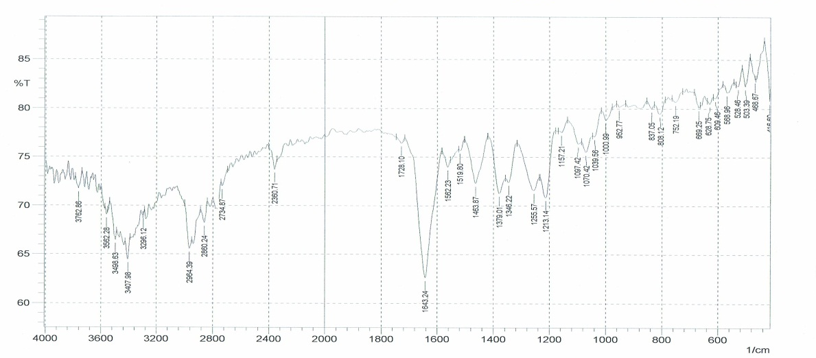
Figure (2): FT-IR spectrum of loaded DOX.
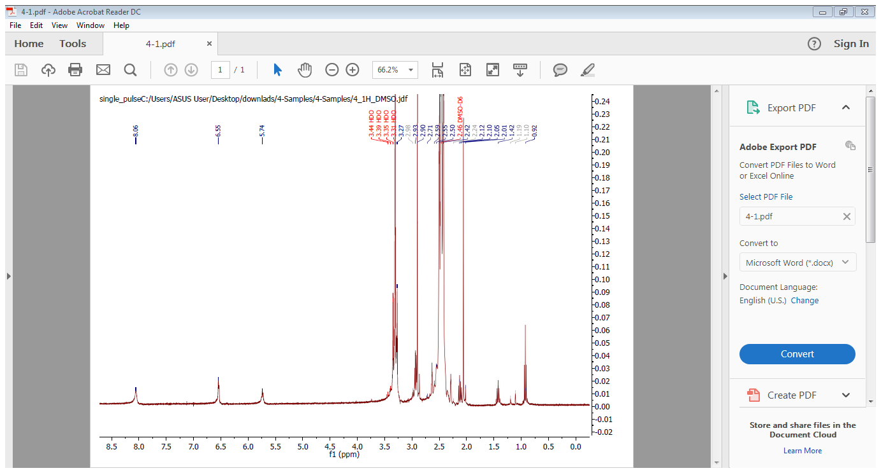
Figure (3): 1H-NMR spectrum of loaded DOX.

3.2. In Vivo Method for Evaluation of Anticancer Activity:
The in vivo method that used to evaluate the anticancer activity of the loaded DOX is done by measuring the ability of the compound to reduce the tumor size that induced in the mice by injection of AM3 adenocarcinoma cells ^{[11]}. The tumor size reduction was measured by vernea and represented by tumor volume (mm³).
3.3. Evaluation of the Anticancer Activity of the Tested Compounds:
The ability of the synthesized nanocarrier to increase the intracellular transportation of DOX and thereby enhance the anticancer activity of DOX had been evaluated in comparison with the unloaded DOX. Table (1) explains the activity of the loaded DOX in different doses compared with the unloaded DOX. Figure (4) showed the effect of the tested compound with statistically significant (P<0.05) reduction in the tumor siz

Table (1): The Anti-Cancer Effect of the Compound (III) in different doses compared with DOX. Each value represents the mean of 5 mice ± SEM.
Tumor volume (mm³) | Compound | Time (day)
Tumor volume (mm³) | Compound | 0 | 3 | 6 | 9 | 12 | 15 | 18 | 21 | 24 | 27
Tumor volume (mm³) | Loaded DOX (1.5mg) | 100  ± 0.00 | 31.05**  ± 9.35 | 39.27**  ± 27.82 | 55.04**  ±30.82 | 61.96**  ± 42.24 | 71.08**  ±37.22 | 92.81**  ±43.81 | 154.79*  ± 40.48 | 195.03  ± 44.09 | 262.66  ± 45.96
Tumor volume (mm³) | Loaded DOX (3mg) | 100  ± 0.00 | 119.03**  ± 71.48 | 75.53**  ± 44.72 | 77.09**  ±50.64 | 109.6**  ±64.86 | 171.8**  ±27.61 | 177.4**  ±95.99 | 258.65*  ± 136.3 | 325.65  ± 187.7 | 618.74  ± 282.47
Tumor volume (mm³) | Loaded DOX (6mg) | 100  ± 0.00 | 53.61*  ± 10.12 | 34.74**  ± 10.53 | 38.02**  ±9.84 | 56.9**  ± 13.35 | 75.48**  ±16.33 | 103.7**  ±22.87 | 146.6**  ±20.9 | 171.58  ±27.61 | 228.04*  ± 43.67
Tumor volume (mm³) | Unloaded DOX (6mg) | 100  ± 0.00 | 55.34  ± 6.05 | 41.00  ±3.17 | 73.69  ±10.06 | 83.88  ±26.57 | 96.95  ± 15.54 | 116.27  ±11.96 | 148.41  ±17.47 | 173.21  ± 21.86 | 178.0  ±19.5

**: significantly different compared to unloaded DOX (P<0.001), *: significantly different compared to unloaded DOX (P<0.05). Time (0) is the time of the first I.p. injection of loaded and unloaded DOX.
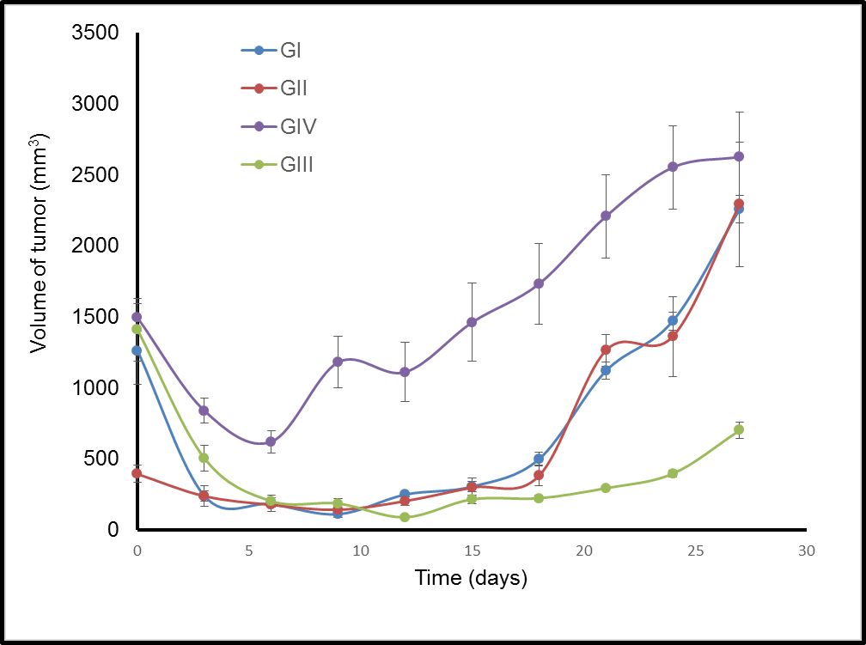

Figure (4): The Anti-Cancer Effect of unloaded DOX and the loaded one in different doses. GI: loaded DOX (1.5mg) ,GII : loaded DOX (3mg) , GIII: loaded DOX (6mg), GIV: unloaded DOX (6mg).

3.4. Interpretations of Fluorescent Pictures of the Prepared slides:
The tumor masses after being preserved in formalin and processed into thin slides were examine by the fluorescent microscope depending on the fluorescent activity of the DOX molecules which appeared as a fluorescent green particles when examined under the fluorescent microscope. This examination took place at the Educational laboratories- Medicine city.
From the images in Figures (5) it was observed that the tumor treated with the loaded DOX contained higher amount of fluorescent particles compared with tumor treated with the unloaded DOX, which means the loaded DOX was successfully transferred in higher amount into the affected cell compared with the unloaded DOX.

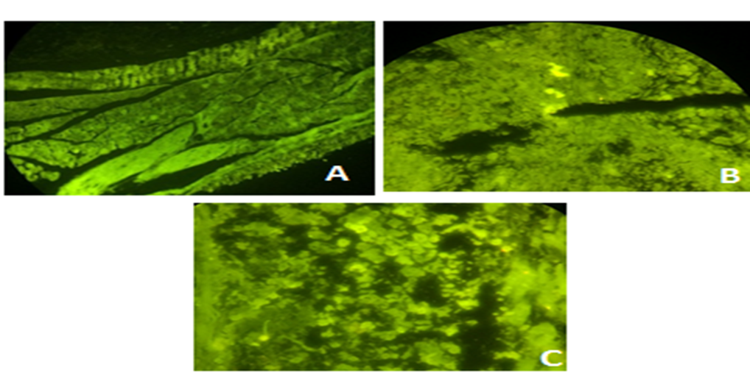
Figure (5): Images of florescent microscope detecting the intensity of the DOX passed into the affected cells. A: untreated tumor B: tumor treated with unloaded DOX C: tumor treated with loaded DOX

Conclusion
The cellulose-based nanocarrier successfully enhanced the anticancer effect of DOX by increasing its transfer into the cancerous cells. This study showed that loaded DOX had higher duration of antitumor effect as compared with the unloaded DOX.
References
1- Ogura, M., Adriamycin (doxorubicin). Gan to kagaku ryoho. Cancer & chemotherapy, 2001. 28(10): p. 1331-1338.
2- Zhao, Y., et al., Doxorubicin and resveratrol co-delivery nanoparticle to overcome doxorubicin resistance. Scientific Reports, 2016. 6: p. 35267.
3- Meredith, A.M. and C.R. Dass, Increasing role of the cancer chemotherapeutic doxorubicin in cellular metabolism. Journal of Pharmacy and Pharmacology, 2016. 68(6): p. 729-741.
4-Thorn, C.F., et al., Doxorubicin pathways: pharmacodynamics and adverse effects. Pharmacogenetics and genomics, 2011. 21(7): p. 440.
5- Agudelo, D., et al., Intercalation of antitumor drug doxorubicin and its analogue by DNA duplex: structural features and biological implications. International journal of biological macromolecules, 2014. 66: p. 144-150.
6- Wong, H.L., et al., A new polymer–lipid hybrid nanoparticle system increases cytotoxicity of doxorubicin against multidrug-resistant human breast cancer cells. Pharmaceutical research, 2006. 23(7): p. 1574-1585.
7- Dash, R. and A.J. Ragauskas, Synthesis of a novel cellulose nanowhisker-based drug delivery system. Rsc Advances, 2012. 2(8): p. 3403-3409.
8- Yang, Z. and P. Sun, Compare of three ways of synthesis of simple Schiff base. Molbank, 2006. 2006(6): p. M514.
9-McMurry, J., Organic Chemistry, Brooks. Cole, New York, 1996: p. 657
10- Al-Shamery, A., The study of newcastle disease virus effect in the treatment of transplanted tumors in mice. Master Of Veterinary Medicine, 2003.
11- Jensen, M.M., et al., Tumor volume in subcutaneous mouse xenografts measured by microCT is more accurate and reproducible than determined by 18 F-FDG-microPET or external caliper. BMC medical imaging, 2008. 8(1): p. 16.
12-Bergman A.M., Adema A.D., and Balzarini J. (2011): Antiproliferative activity, mechanism of action and oral antitumor activity of CP -4126, a fatty acid derivative of gemcitabine, in invitro and in vivo tumor models. Invest New Drugs, 29:456-466.

